The Impacts of the 2008 Hurricane Season On
Trinidad and Tobago

The 2008 Atlantic hurricane season has been an active one, especially within the Caribbean Region. All tropical cyclones which formed in the Atlantic Basin passed to the north of Trinidad and Tobago, as such there were no direct impact from any cyclones.
Spiral bands associated with Hurricane Omar during the month of October affected both Trinidad and Tobago to some small degree. No flooding, property damage or agricultural loses were attributed to the passage of this system.
On the 7th September, flood waters swept away a 30 month old baby girl who slipped out of her mother’s arms and drowned while crossing Crooks’ River at Rockleyvale, Scarorobough – Tobago. The raging floodwaters also caused extensive damage to homes, agricultural crops and poultry farms in Southern areas of Trinidad. Torrential downpours on Tuesday 18th November in Port of Spain and its environs produced extensive flooding in the heart of the city. In fact there was a complete shutdown of transportation for more than eight hours in many parts of the city. Two deaths occurred due to this rainfall event. Debris and silt due to this event is still visible in many areas up to today.
During the early part of the season there were marked increases in the incidence of flash flooding, particularly in Trinidad. The Meteorological Services attributes this partially to a slight increase in rainfall intensities coupled with clogged waterways/watercourses and faster run-offs which have occurred as a result of widespread housing and infrastructural developments. This resulted in the Meteorological Services ‘reintroducing’ the issuing of Information Bulletins, as oppose to Severe Weather Bulletins, for events that were to last for a period of two to four hours but were forecast to produce street flooding and/or flash flooding. What is also worth mentioning is the increase in sightings of funnel clouds both on-land and off-shore during the entire Hurricane Season.
The Meteorological Services received increasing demands from stakeholders both in the private and public sectors for a seven day weather outlook. Due to the limited resources available in generating a resilient and sustained seven day forecast, the Office introduced a four day outlook beginning Monday evening and ending Friday afternoon together with a three day outlook, beginning Friday evening and ending Monday afternoon. The outlook includes a colour coded probability scheme, which highlights different levels of probabilities. (See Appendix D)

.

Several other severe weather episodes occurred over Trinidad and Tobago during the hurricane season of 2008 and can be attributed to the passage of Tropical Waves and ITCZ dominance. Also, the passage of tropical cyclones well to the north of the Islands of the Eastern Caribbean, resulted in a breakdown of the low-mid level wind-field over Trinidad, temperatures soured in excess of 35 degrees Celsius at times, these conditions assisted in the development of west coast convection (land-sea breeze effect) which produced flooding in Port-of-Spain and environs and other parts of Western Trinidad sporadically during the months of September, October and November.

SUMMARY OF BULLETINS ISSUED

Severe Weather Bulletins

The first bulletin for the 2008 season was issued on the 23rd August and this was an Information Bulletin which was issued at 8:00 a.m. and this was followed by a Severe Weather Bulletin which was issued on the same day at 3 p.m. This was due to a low pressure system which resulted in severe weather affecting Trinidad, Tobago, Grenada and its Dependencies.

An Information bulletin was issued at 2:00 pm on Wednesday 27th August informing the general public of the possibility of torrential showers and thundershowers during the afternoon period. South Trinidad experienced flooding following several periods of torrential rainfall on Wednesday 27th August. Parts of the Solomon Hochoy Highway - the main link between South and North Trinidad - were under water, leading to hundreds of motorists being stranded. (See photos in Appendix A).
Motorists were forced to stop their cars and wait while others had no choice but to push their vehicles to the shoulder of the highway after their vehicles stalled. Some motorists had to wait for over three hours before the waters subsided sufficiently for them to proceed.

A Bulletin was issued on the 7th September 2008 for Trinidad and Tobago due to the passage of a very active Tropical Wave which was enhanced by an upper level trough and the maximum temperature rose to 34.8 C. Scattered showers and thundershowers occurred from mid-morning until late evening. Flooding occurred in many areas in both Trinidad and Tobago. On this day regretfully, Tobago recorded the death of a child due to raging flood waters. Images from Tobago due to this meteorological event are highlighted in Appendix B.

On the 3rd October, Severe Weather Bulletin #1 was issued at 7:00 a.m. for both Trinidad and Tobago. This was due to the passage of an active Tropical Wave and an upper-level low which provided the necessary upper level diffluent flow, at 12:30 p.m. the bulletin was discontinued. Confirmed reports from Tobago indicated that the roof of Lambeau E.C. School was partially blown off and there was extensive flooding damage, power lines in the Mount Pleasant area were also severely affected.

Widespread rainfall over the period 14th to 19th November resulted in two (2) deaths, extensive damage to properties, livestock and the agricultural industry. Nathaniel Poon (three years old) was killed after landslide destroyed her St Anns home on Tuesday 18th November. Pensioner Barbara Emmanuel, 67, was killed after landslide destroyed her Le Platte Village, Maraval home on Sunday 16th November. Dozens of cars had to be wrecked after being washed away in floods over the weekend; one bridge on the east-bound lane of the Churchill Roosevelt Highway collapsed into the river; houses in Mon Repos and Laventille, collapsed. Several areas suffered after Landslides wreaked havoc in their locality viz. La Platte Village, Maraval, Maracas, Lady Young Road, Morvant and some others. A number of Severe Weather Bulletins and Information Bulletins were issued during this period.
(See Appendix C).

Information Bulletins

Information Bulletins and Severe Weather Bulletins dates are tabled below:

 | JUNE | JULY | AUGUST | SEPTEMBER | OCTOBER | NOVEMBER
1st | - | - | - | - | - | -
2nd | - | - | - | - | - | -
3rd | - | - | - | SWB - T | IB - T | -
4th | - | - | - | - | - | -
5th | - | - | - | - | - | -
6th | - | - | - |  | - | -
7th | - | - | - | SWB – T - U | - | -
8th | - | - | - | IB – I - U | IB - U | -
9th | - | - | - | - | IB - T | -
10th | - | - | - | - | IB – I - T | -
11th | - | - | - | IB - D | - | -
12th | - | - | -- | - | - | -
13th | - | - | - | - | - | -
14th | - | - | - | - | - | IB - I
15th | - | - | - | - | - | IB - I
16th | - | - | - | - | - | IB - I
17th | - | - | - | - | - | IB - I
18th | - | - | - | - | - | IB - D
19th | - | - | - | - | IB – T - I | IB - D
20th | - | - | - | - | - | -
21st | - | - | - | - | - | -
22nd | - | - | - | - | -
23rd | - | - | IB - SWB - L | - | IB - D
24th | - | - | - | - | IB - D
25th | - | - | - | - | -
26th | - | - | - | - | -
27th | - | - | - | IB - D | -
28th | - | - | - | IB - D | -
29th | - | - | - | IB - D | -
30th | - | - | - | - | -
31st |  | - | - |  | - | -

Legend: L = Low Pressure System U = Upper Level Trough / Diffluence
I = ITCZ T = Tropical Wave
D = Diurnal Convection IB = Information Bulletin
SWB = Severe Weather Bulletin

Appendix A

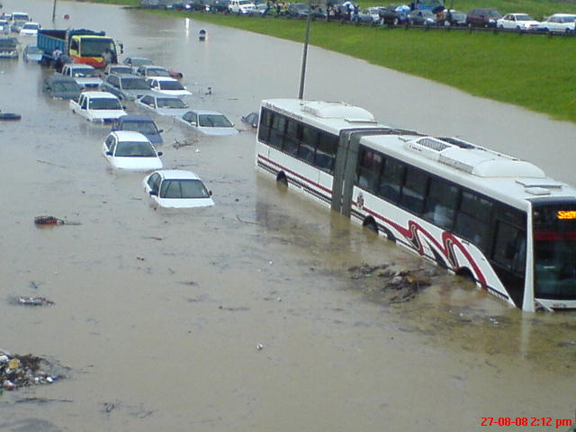

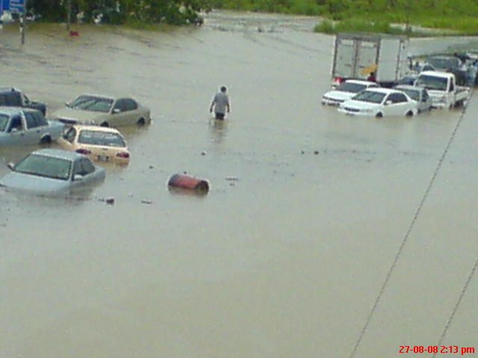

Appendix B

MAJOR FLOODING AT DOWN TOWN SCARBOROUGH ON Sept. 7th 2008. DUE TO HEAVY RAINS IN THE EARLY HOURS OF THE MORNING RESULTING IN MAJOR FLOODING DOWNTOWN SCARBOROUGH. THE FOLLOWING AREAS WERE IMPACTED: GARDEN SIDE STREET, CARRINGTON STREET, MILFORD ROAD AND WILSON ROAD. A NUMBER OF BANKS AND SEVERAL BUSINESS PLACES WERE FLOODED OUT. NO ESTIMATE OF DAMAGES WAS REPORTED.

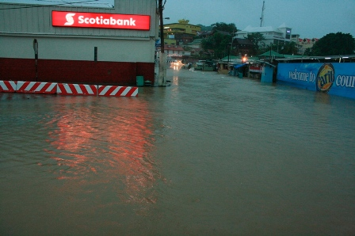

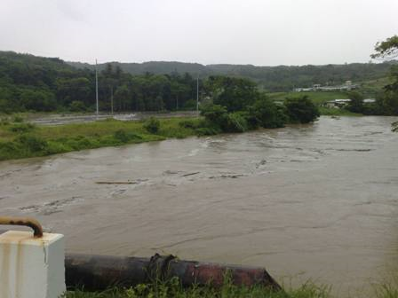

Appendix C

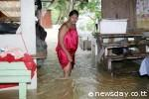



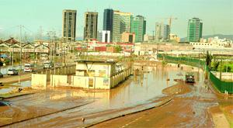

mpassable: The eastern end of South Quay, Port of Spain, was still impassable yesterday morning as the floodwaters remained from Tuesday's downpour. -Photo: DELLA ANN STEWART

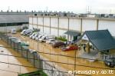

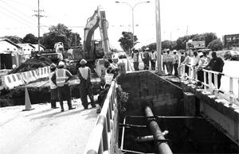
BIG MESS: Workmen at the site yesterday where a bridge along the east-bound lane of the Churchill-Roosevelt Highway, just after the Macoya intersection, caved in on Monday night. - Photo: ABRAHAM DIAZ

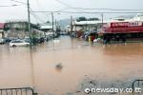

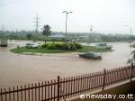

Appendix D

THREE-DAY WEATHER OUTLOOK

DATE: FRIDAY 26TH SEPTEMBER 2008 ISSUED AT: 3.00PM

FRIDAY 26TH – EVENING/NIGHT (CODE BLUE)

GENERALLY FAIR
CHANCE OF ISOLATED SHOWERS
SYNOPSIS: RIDGE OF HIGH PRESSURE IN GENERAL AREA.

SATURDAY 27TH – (CODE BLUE)

FAIR TO PARTLY CLOUDY
ISOLATED SHOWERS WITH CHANCE OF AFTERNOON THUNDERSHOWER
SYNOPSIS: RIDGE OF HIGH PRESSURE IN GENERAL AREA

SUNDAY 14TH – (CODE ORANGE)

OCCASIONAL SHOWERS AND ISOLATED THUNDERSHOWERS.
THERE IS THE CHANCE OF STREET AND FLASH FLOODING AND GUSTY WINDS IN THUNDERSHOWERS. THIS IS FORECAST TO BEGIN BY AFTERNOON AND MAY CONTINUE FOR AT LEAST A FEW HOURS.
SYNOPSIS: FRONT-END OF TROPICAL WAVE OVER TRINIDAD AND TOBAGO.

MONDAY 15TH – (CODE ORANGE)

OCCASIONAL SHOWERS AND ISOLATED THUNDERSHOWERS
THE PROBABILITY OF STREET AND FLASH FLOODING AND GUSTY WINDS WILL CONTINUE.
SYNOPSIS: DUE TO PASSAGE OF TROPICAL WAVE

TROPICAL STORM ACTIVITY IS NOT EXPECTED TO AFFECT T&T DURING THIS PERIOD

Status Code:
BLUE: NO SIGNIFICANT WEATHER FEATURES (PROBABILITY < 25%)
GREEN: LOW POTENTIAL OF SIGNIFICANT WEATHER (PROBABILITY >25% <40%)
ORANGE: MEDIUM POTENTIAL OF SIGNIFICANT (SEVERE) WEATHER (PROBABILITY >40% <70%)
RED: HIGH POTENTIAL OF SIGNIFICANT OR SEVERE WEATHER
(PROBABILITY > 70%)

M. Noel
Ag. Assistant Director

Submitted by Marlon Noel
Written by Marlon Noel & Shakeer Baig

